**Visual Studio IDE**

Visual Studio is a powerful and customizable programming environment that contains all the tools you need to build programs quickly and efficiently. It offers a set of tools that help you write and modify the code for your programs, and also detect and correct errors in your programs.

Before you start learning more about VB.NET programming, it is important to understand the development environment and identify some of the frequently using programming tools in Visual Studio IDE.

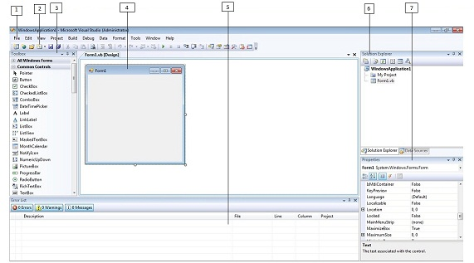

* 1. Menu Bar
* 2. Standard Toolbar
* 3. ToolBox
* 4. Forms Designer
* 5. Output Window
* 6. Solution Explorer
* 7. Properties Window

Visual Basic.NET IDE is built out of a collection of different windows. Some windows are used for writing code, some for designing interfaces, and others for getting a general overview of files or classes in your application.

Visual Studio organizes your work in projects and solutions. A solution can contain more than one project, such as a DLL and an executable that references that DLL. From the following chapters you will learn how to use these Visual Studio features for your programming needs.

EXAMPLE : **WAP IN VB.NET INPUT TWO NOS AND FIND THE SUM USING WINDOW FORM**

[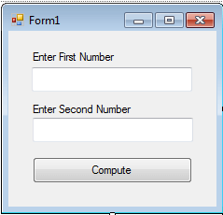](https://www.inettutor.com/wp-content/uploads/2015/06/sumoftwo1.png)

.

**Code for Subtraction of two numbers in Windows Form Application using VB.net**  
Public Class Form1  
    Private Sub btnCompute_Click(ByVal sender As System.Object, ByVal e As System.EventArgs) Handles btnCompute.Click  
       txttotal.Text = Val(txtNum1.Text) +Val(txtnum2.Text)  
  
    End Sub  
End Class